[Home](https://techtfq.com/) [Courses](https://techtfq.graphy.com/s/store?redirectToMicroFE=true) [Blog](https://techtfq.com/blog-1) [Contact](https://techtfq.com/contact) Login

# Learn how to write SQL Queries(Practice Complex SQL Queries)

Learning SQL syntax is very easy but getting comfortable in writing SQL Queries, especially the complex SQL Queries can be tricky and will need a lot of practice.

In this blog, I have listed below **9 SQL Queries** which should help you to practice intermediate to complex SQL queries.

You will find below SQL Questions along with the data and table structure required to solve each SQL question. The SQL Query to solve these questions will be attached to an .txt file. You can simple download the file for each question to get the solved SQL Queries.



*\*\*\* Note: Please note, I have used PostgreSQL database to executed all of these*

*queries. I believe these queries would work just fine with any other major RDBMS such*



*as Oracle, MySQL, Microsoft SQL Server. However, if you find any query not working in*



*your RDBMS, then leave a comment below so I could help.*

## Write a SQL Query to fetch all the duplicate records in a table.

**Table Name**: USERS

**Note**: Record is considered duplicate if a user name is present more than once.

**Approach**: Partition the data based on user name and then give a row number to each of the partitioned user name. If a user name exists more than once then

it would have multiple row numbers. Using the row number which is other than 1, we can identify the duplicate records.

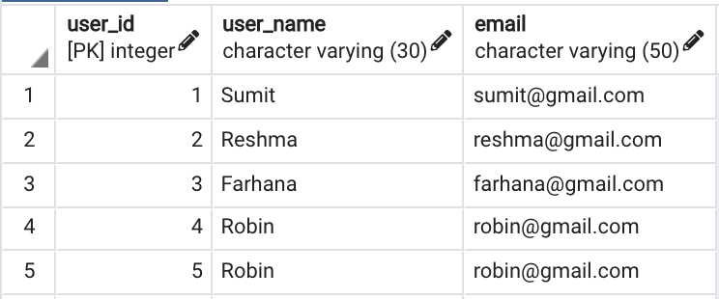

USERS

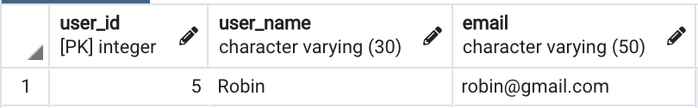

### Expected Output

There are several ways to write this query. Such as either using the CTID field in PostgreSQL or by using the ROWID field in Oracle, MySQL, Microsoft SQL Server etc but a simpler way to write this query would be using window function.

Try to write this query yourself before looking the query I have written to solve it.

Click on the download button below to download the .txt file which will have the table structure, table data and the solved SQL Query.

[Download Script - Query 1](https://techtfq.com/s/Query-1-Script.txt)

## Write a SQL query to fetch the second last record from employee table.

**Table Name**: EMPLOYEE

**Approach**: Using window function sort the data in descending order based on employee id. Provide a row number to each of the record and fetch the record having row number as 2.

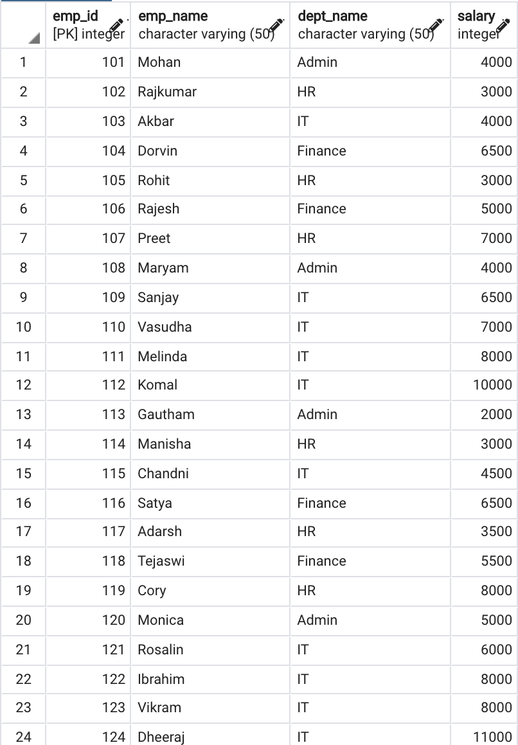



EMPLOYEE

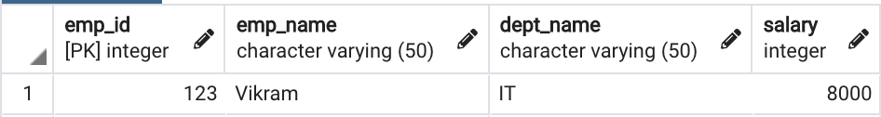

### Expected Output

Again, there are several ways to write this query but this becomes very simple using a window function.

Try to write this query yourself before looking the query I have written to solve it.

Click on the download button below to download the .txt file which will have the table structure, table data and the solved SQL Query.

[Download Script - Query 2](https://techtfq.com/s/Query-2-Script.txt)

## Write a SQL query to display only the details of employees who either earn the highest salary or the lowest salary in each department from the employee table.

**Table Name**: EMPLOYEE

**Approach**: Write a sub query which will partition the data based on each department and then identify the record with maximum and minimum salary for each of the partitioned department. Finally, from the main query fetch only the data which matches the maximum and minimum salary returned from the sub query.

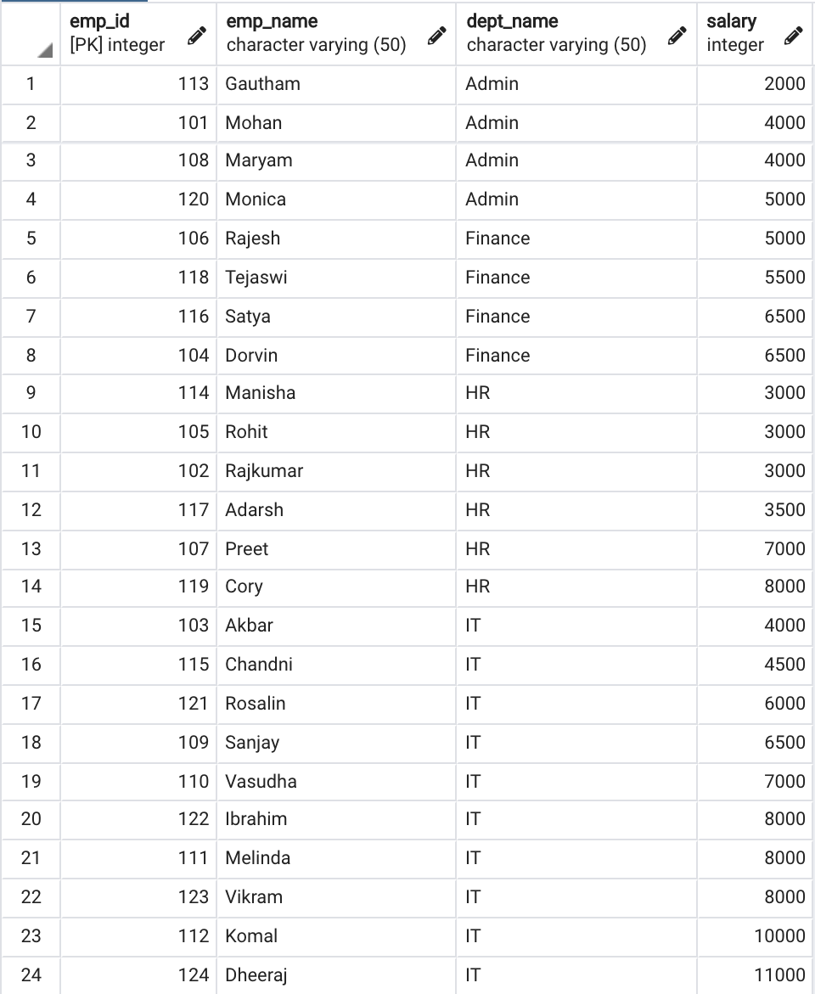

EMPLOYEE

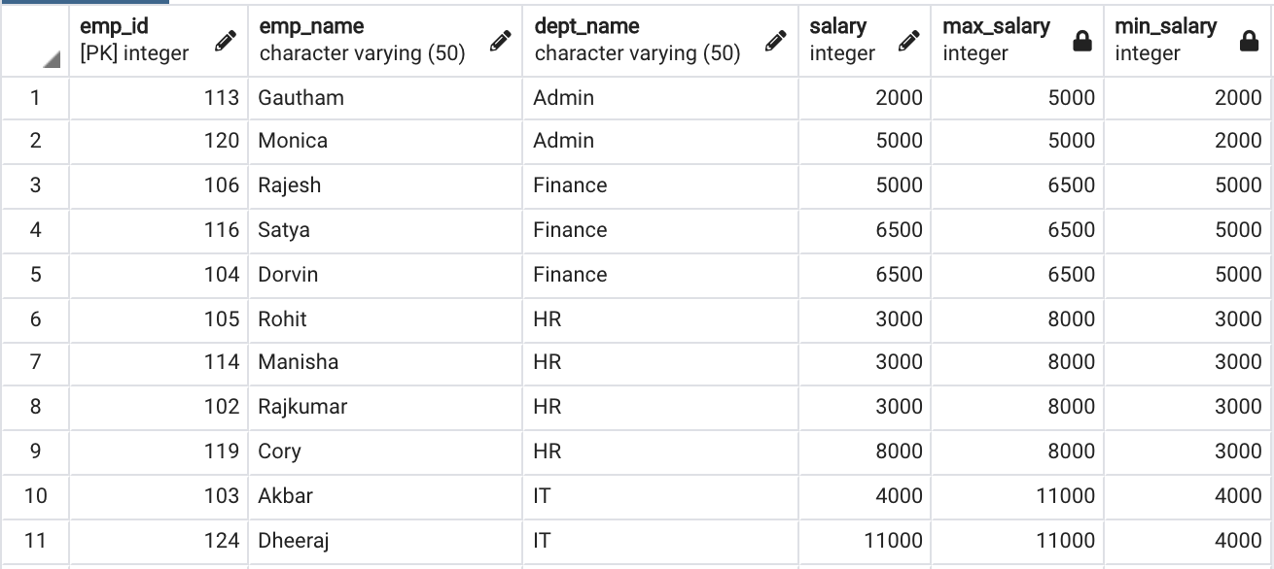

### Expected Output

Again there are many way to do this and also we can use a few window functions to achieve the same result. As an added challenge, try out solving this query using a different window function and then comment out your query.

Click on the download button below to download the .txt file which will have the table structure, table data and the solved SQL Query.

[Download Script - Query 3](https://techtfq.com/s/Query-3-Script.txt)

## From the doctors table, fetch the details of doctors who work in the same hospital but in different specialty.

**Table Name**: DOCTORS

**Approach**: Use self join to solve this problem. Self join is when you join a table to itself.

**Additional Query**: Write SQL query to fetch the doctors who work in same hospital irrespective of their specialty.

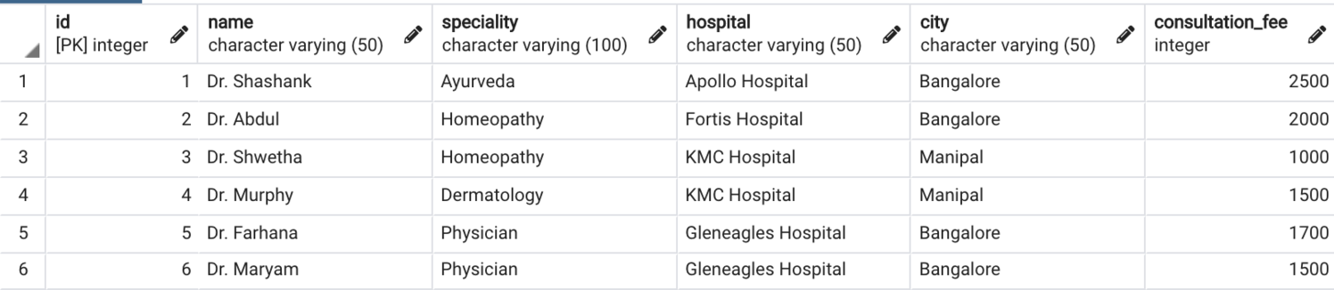

DOCTORS

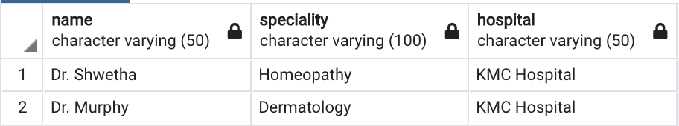

**Expected Output:** Same hospital different speciality

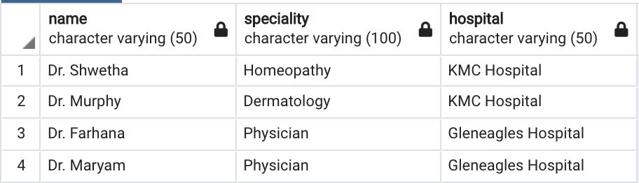

**Expected Output:** Same hospital irrespective of speciality

Click on the download button below to download the .txt file which will have the table structure, table data and the solved SQL Query.

[Download Script - Query 4](https://techtfq.com/s/Query-4-Script.txt)

## From the login_details table, fetch the users who logged in consecutively 3 or more times.

**Table Name**: LOGIN_DETAILS

**Approach**: We need to fetch users who have appeared 3 or more times consecutively in login details table. There is a window function which can be used to fetch data from the following record. Use that window function to compare the user name in current row with user name in the next row and in the row following the next row. If it matches then fetch those records.

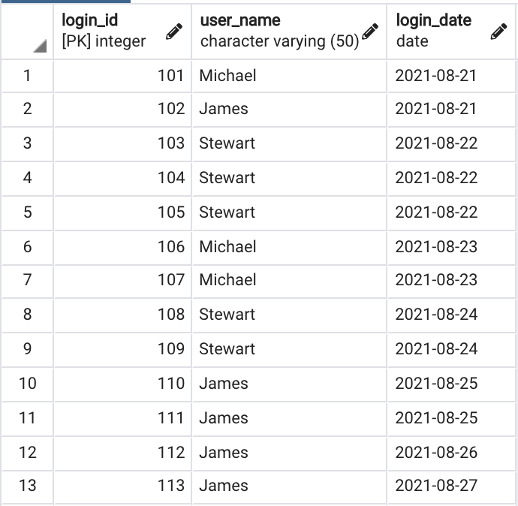

LOGIN_DETAILS

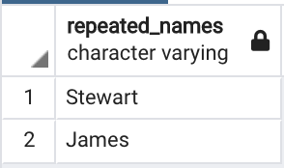

### Expected Output

Click on the download button below to download the .txt file which will have the table structure, table data and the solved SQL Query.

[Download Script - Query 5](https://techtfq.com/s/Query-5-Script.txt)

## From the students table, write a SQL query to interchange the adjacent student names.

**Note**: If there are no adjacent student then the student name should stay the same.

**Table Name**: STUDENTS

**Approach**: Assuming id will be a sequential number always. If id is an odd number then fetch the student name from the following record. If id is an even number then fetch the student name from the preceding record. Try to figure out the window function which can be used to fetch the preceding the following record data.

If the last record is an odd number then it wont have any adjacent even number hence figure out a way to not interchange the last record data.

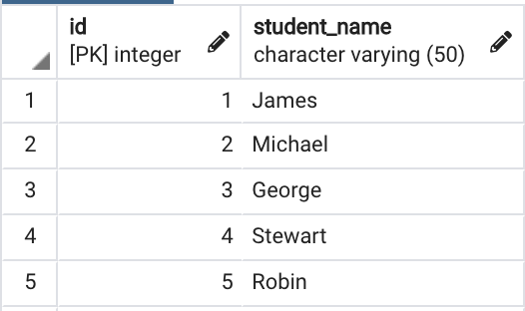

STUDENTS

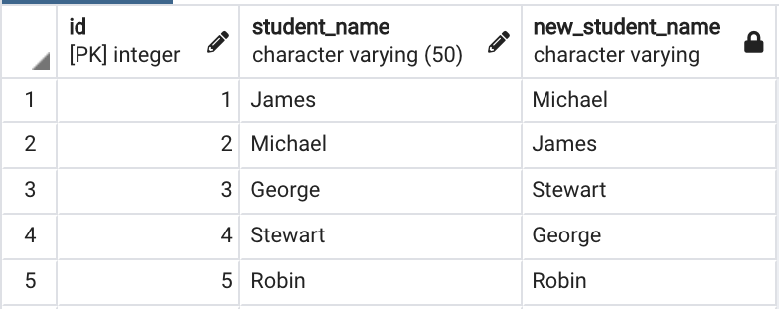

### Expected Output

Click on the download button below to download the .txt file which will have the table structure, table data and the solved SQL Query.

[Download Script - Query 6](https://techtfq.com/s/Query-6-Script-rkw9.txt)

## From the weather table, fetch all the records when London had extremely cold temperature for 3 consecutive days or more.

**Note**: Weather is considered to be extremely cold when its temperature is less than zero.

**Table Name**: WEATHER

**Approach**: First using a sub query identify all the records where the temperature was very cold and then use a main query to fetch only the records returned as very cold from the sub query. You will not only need to compare the records following the current row but also need to compare the records preceding the current row. And may also need to compare rows preceding and following the current row. Identify a window function which can do this comparison pretty easily.

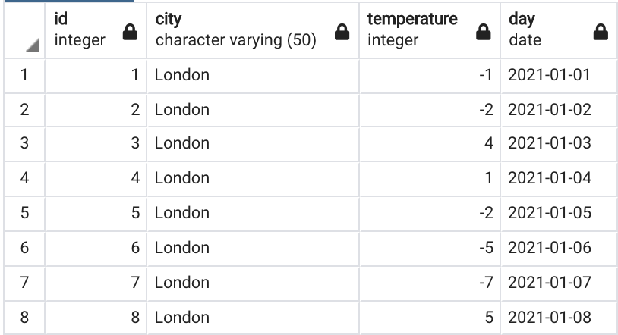

WEATHER

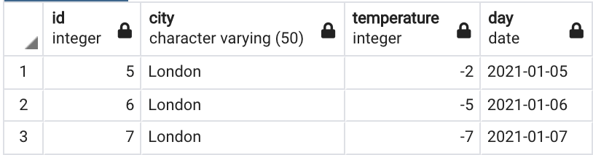

### Expected Output

Click on the download button below to download the .txt file which will have the table structure, table data and the solved SQL Query.

[Download Script - Query 7](https://techtfq.com/s/Query-7-Script.txt)

## From the following 3 tables (event_category, physician_speciality, patient_treatment), write a SQL query to get the histogram of specialties of the unique physicians who have done the procedures but never did prescribe anything.

**Table Name**: EVENT_CATEGORY, PHYSICIAN_SPECIALITY, PATIENT_TREATMENT

**Approach**: Using the patient treatment and event category table, identify all the physicians who have done “Prescription”. Have this recorded in a sub query.

Then in the main query join the patient treatment, event category and physician speciality table to identify all the physician who have done “Procedure”. From these physicians, remove those physicians you got from sub query to return the physicians who have done Procedure but never did Prescription.

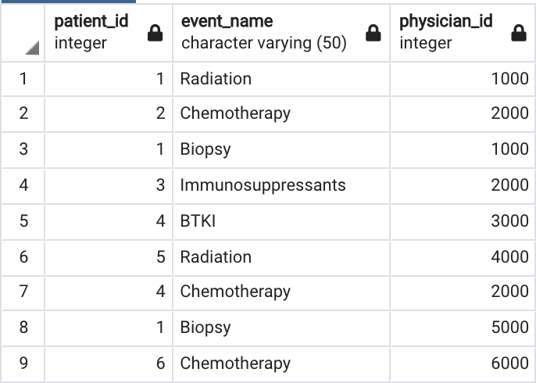

PATIENT_TREATMENT

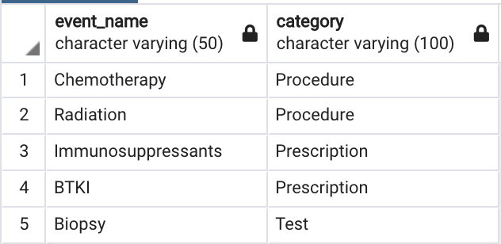

EVENT_CATEGORY

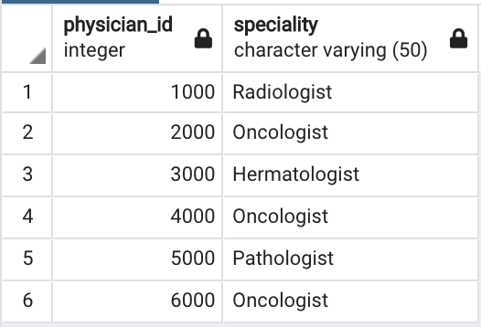

PHYSICIAN_SPECIALITY

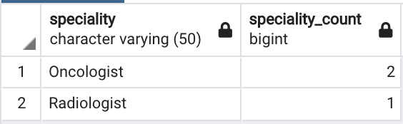

### Expected Output

Click on the download button below to download the .txt file which will have the table structure, table data and the solved SQL Query.

[Download Script - Query 8](https://techtfq.com/s/Query-8-Script.txt)

## Find the top 2 accounts with the maximum number of unique patients on a monthly basis.

**Note**: Prefer the account id with the least value in case of same number of unique patients

**Table Name**: PATIENT_LOGS

**Approach**: First convert the date to month format since we need the output specific to each month. Then group together all data based on each month and account id so you get the total no of patients belonging to each account per month basis.

Then rank this data as per no of patients in descending order and account id in ascending order so in case there are same no of patients present under multiple account if then the ranking will prefer the account if with lower value. Finally, choose upto 2 records only per month to arrive at the final output.

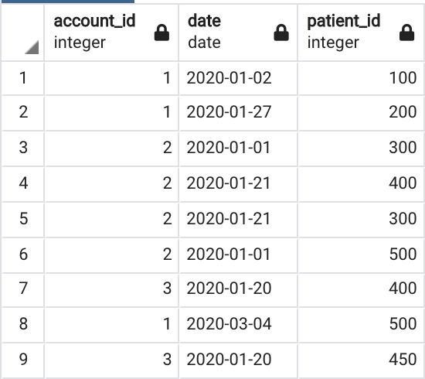

PATIENT_LOGS

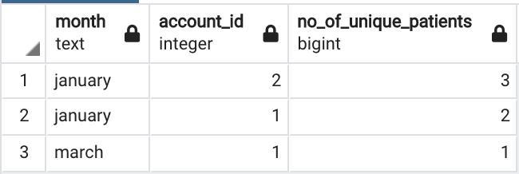

### Expected Output

Click on the download button below to download the .txt file which will have the table

structure, table data and the solved SQL Query.

[Download Script - Query 9](https://techtfq.com/s/Query-9-Script.txt)

## SQL Query to fetch “N” consecutive records from a table based on a certain condition

Note: Write separate queries to satisfy following scenarios: 10a. when the table has a primary key

10b. When table does not have a primary key 10c. Query logic based on data field

10a. when the table has a primary key Table Name: WEATHER

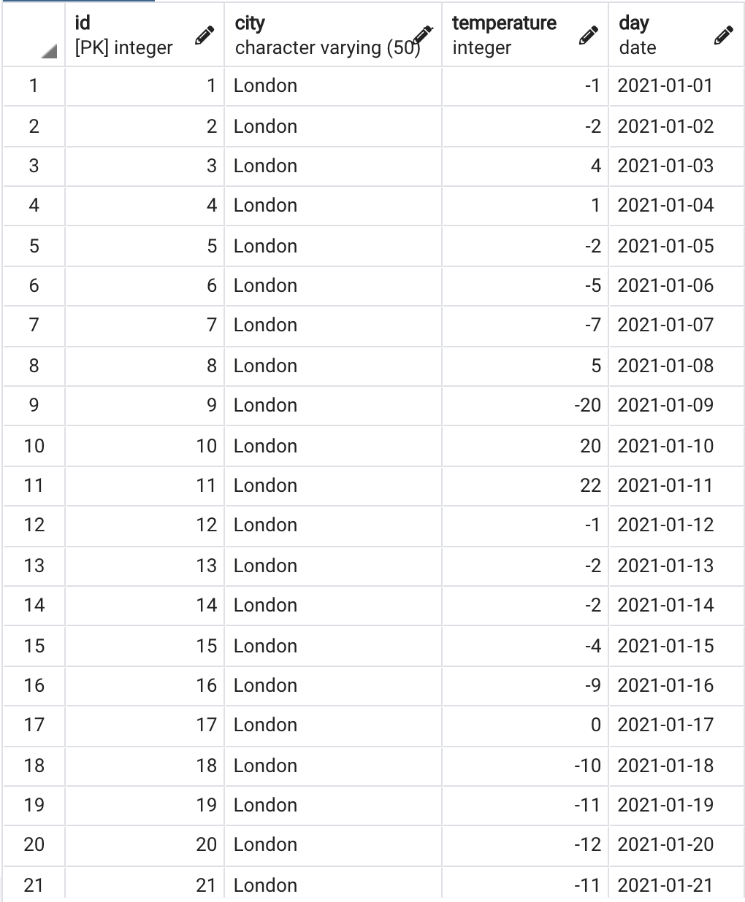

### WEATHER table Data

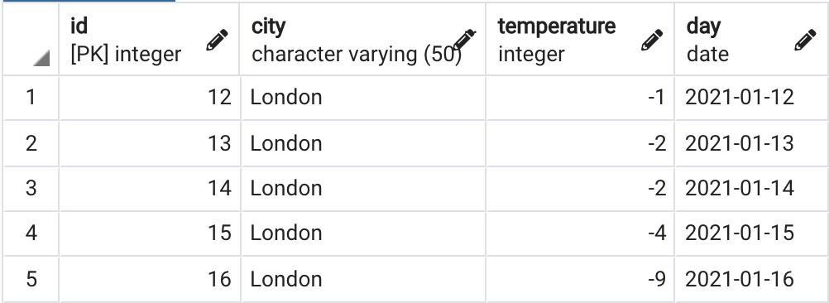

**10a: Expected Output**

10b. When table does not have a primary key Table Name: VW_WEATHER

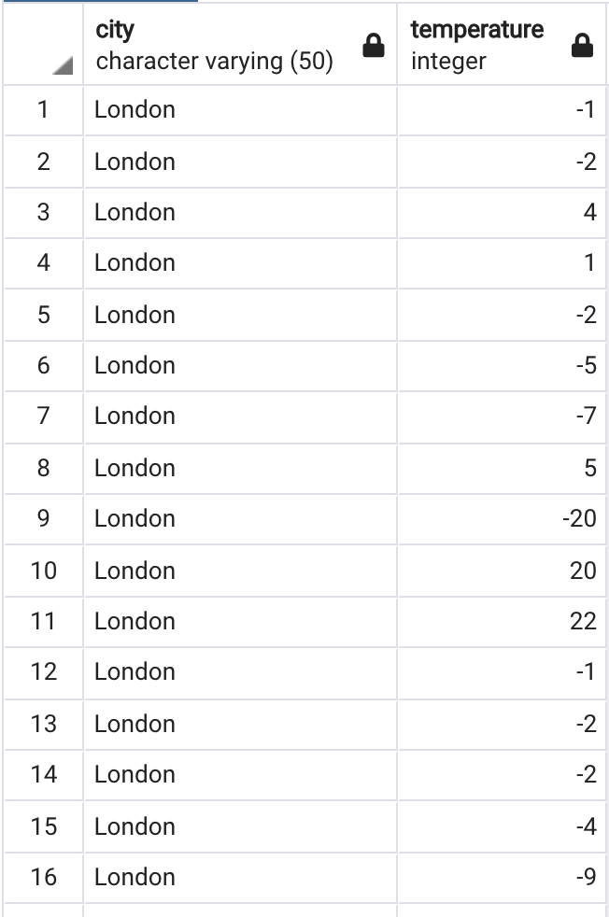

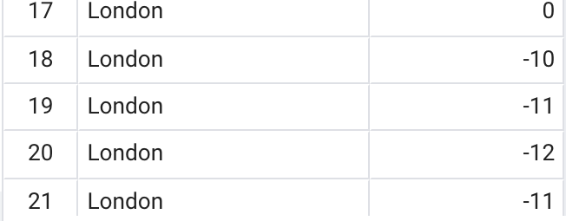

### VW_WEATHER table data

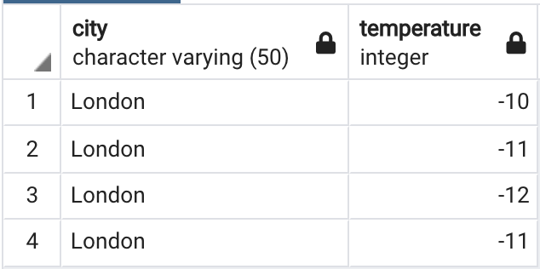

**10b: Expected Output**

10c. Query logic based on data field Table Name: ORDERS

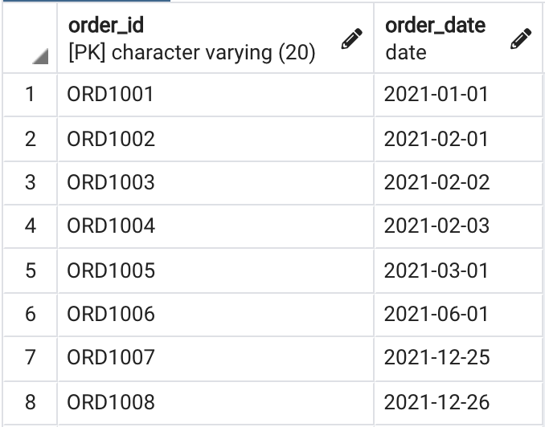

### ORDERS table data

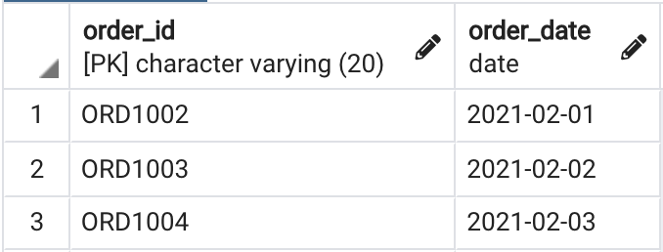

**10c: Expected Output**

[Download Scripts](https://techtfq.com/s/Query_10_SQL_Scripts.txt)

[how to write complex sql queries](https://techtfq.com/blog/tag/how%2Bto%2Bwrite%2Bcomplex%2Bsql%2Bqueries) • [learn how to write sql queries](https://techtfq.com/blog/tag/learn%2Bhow%2Bto%2Bwrite%2Bsql%2Bqueries) • [practice complex](https://techtfq.com/blog/tag/practice%2Bcomplex%2Bsql%2Bqueries) [sql queries](https://techtfq.com/blog/tag/practice%2Bcomplex%2Bsql%2Bqueries) • [Learn how to write SQL Queries(Practice Complex SQL Queries)](https://techtfq.com/blog/tag/Learn%2Bhow%2Bto%2Bwrite%2BSQL%2BQueries%28Practice%2BComplex%2BSQL%2BQueries%29) • [Learn](https://techtfq.com/blog/tag/Learn%2Bhow%2Bto%2Bwrite%2BSQL%2BQueries%2B%28Practice%2BComplex%2BSQL%2BQueries%29) [how to write SQL Queries (Practice Complex SQL Queries)](https://techtfq.com/blog/tag/Learn%2Bhow%2Bto%2Bwrite%2BSQL%2BQueries%2B%28Practice%2BComplex%2BSQL%2BQueries%29) • [sql queries](https://techtfq.com/blog/tag/sql%2Bqueries) • [practice sql](https://techtfq.com/blog/tag/practice%2Bsql%2Bqueries) [queries](https://techtfq.com/blog/tag/practice%2Bsql%2Bqueries) • [how to write sql queries](https://techtfq.com/blog/tag/how%2Bto%2Bwrite%2Bsql%2Bqueries) • [sql query](https://techtfq.com/blog/tag/sql%2Bquery) • [sql queries using window](https://techtfq.com/blog/tag/sql%2Bqueries%2Busing%2Bwindow%2Bfunctions)

[functions](https://techtfq.com/blog/tag/sql%2Bqueries%2Busing%2Bwindow%2Bfunctions) • [sql queries using window function](https://techtfq.com/blog/tag/sql%2Bqueries%2Busing%2Bwindow%2Bfunction) • [window function sql queries](https://techtfq.com/blog/tag/window%2Bfunction%2Bsql%2Bqueries) • [sql](https://techtfq.com/blog/tag/sql%2Bquery%2Busing%2Bself%2Bjoin) [query using self join](https://techtfq.com/blog/tag/sql%2Bquery%2Busing%2Bself%2Bjoin) • [complex sql queries](https://techtfq.com/blog/tag/complex%2Bsql%2Bqueries) • [sql](https://techtfq.com/blog/tag/sql) • [query](https://techtfq.com/blog/tag/query) • [writing sql](https://techtfq.com/blog/tag/writing%2Bsql%2Bquery)

[query](https://techtfq.com/blog/tag/writing%2Bsql%2Bquery) • [practicing sql query](https://techtfq.com/blog/tag/practicing%2Bsql%2Bquery) • [sql query writing](https://techtfq.com/blog/tag/sql%2Bquery%2Bwriting) • [practice sql](https://techtfq.com/blog/tag/practice%2Bsql) • [learn sql](https://techtfq.com/blog/tag/learn%2Bsql) • [learn sql](https://techtfq.com/blog/tag/learn%2Bsql%2Bquery) [query](https://techtfq.com/blog/tag/learn%2Bsql%2Bquery)

## Comments (143)

Newest First

Preview

Post Comment…

 **Ebubechi Nwogodor** 2 weeks ago · 0 Likes

Q3: correct query to display only the details of employees who either earn the highest salary or the lowest salary in each department from the employee table.

select emp_ID,emp_NAME,DEPT_NAME,SALARY,MAX_SALARY,MIN_SALARY

from( select *,

max(salary) over(partition by DEPT_NAME) as MAX_SALARY, min(salary) over(partition by DEPT_NAME) as MIN_SALARY from employee) x

where salary in (X.MAX_SALARY) or salary in (x.MIN_SALARY);

 **Kiran Gowda** 2 months ago · 0 Likes

Correct Query for the Problem Statement Max 2 Acocunts WITH noof AS

(

SELECT account_id,MonthName,NoOfPatients

,ROW_NUMBER() OVER(PARTITION BY MonthName ORDER BY

account_id,NoOfPatients DESC) Rwnm FROM

(

SELECT account_id,MonthName,COUNT(DISTINCT patient_id) NoOfPatients FROM

(

select account_id,DATENAME(MONTH, Date) MonthName,patient_id from patient_logs

)In1

GROUP BY account_id,MonthName

)MaxAcc

)

SELECT account_id,MonthName,NoOfPatients FROM noof WHERE Rwnm >1

 **Kiran Gowda** 2 months ago · 0 Likes

top 2 accounts with the maximum number of unique patients on a monthly basis.

 **Kiran Gowda** 2 months ago · 0 Likes

TO Get Randomly TOP 2 Accounts Without knowing the number to filter in rownumber when data is more

SELECT TOP 2 * FROM (

SELECT account_id,MOnthnme,DistinctPatnts

,ROW_NUMBER() OVER (ORDER BY account_id,MOnthnme) Rnm FROM

(

SELECT account_id,MOnthnme,COUNT(DISTINCT patient_id) DistinctPatnts

FROM (

SELECT account_id, DATENAME(MONTH, date) MOnthnme, patient_id FROM patient_logs

) noofptnts

GROUP BY account_id,MOnthnme

)rwnm

)tp ORDER BY Rnm DESC

**Bhaskar Nain** 4 months ago · 0 Likes

I'm unable to create a table in 1st question. I wrote every query right for creating a table but still it's showing Table "users" must be qualified with a dataset (e.g. dataset.table) in query results. How to fix this issue please help!

 **salim** 3 months ago · 0 Likes

I am able to create table. Show me your syntex

 **Hasan** 4 months ago · 0 Likes

Sir,

please upload a session for CTE and window function using lead and lag to clear the concepts.

 **dj** 7 months ago · 0 Likes

10 C:

is this approach correct ?

with cte1 as (select a.*,TO_CHAR(ORDER_DATE, 'MONTH') as day from orders a), cte2 as (

select b.*, count(*) over(partition by day) as rk from cte1 b)

select order_id, order_date from cte2

where rk >= 3

order by order_date

 **Thejo Prasad** 9 months ago · 0 Likes

Q5 : I think This solution would by easy

select Distinct user_name from login_details a where exists

(select 1 from login_details b where a.login_id+1 = b.login_id and a.user_name

=b.user_name)

and exists (select 1 from login_details c where a.login_id+2 = c.login_id and a.user_name =c.user_name)

 **Mukka Santhosh Narasimha** 9 months ago · 0 Likes

6.

with naing as (select *, ntile(3) over() as ok from students), haming as ( select *,

last_value(student_name) over(partition by ok) as yum,

first_value(student_name) over( partition by ok ) yumm from naing), hamingg as ( select *,

case when id % 2 != 0 then yum else yumm end as okk from haming ) select id, student_name, okk as new_student_name from hamingg

 **Santanu** 9 months ago · 0 Likes

* 1. with cte as (select to_char(date,'Month') as month,account_id,count(distinct patient_id) as no_of_unique_patints,row_number() over(partition by to_char(date,'Month') order by count(distinct patient_id) desc ) as rn from patient_logs

group by to_char(date,'Month'),account_id)

select month,account_id,no_of_unique_patints from cte where rn<=2

 **Nitish Kumar** 9 months ago · 0 Likes

query 9 . Here is more simpler and readable query.

with cte as (

select account_id, monthname(date) as month_name, count(distinct(patient_id)) as unique_visit

from patient_logs

group by account_id,month_name), cte2 as(

select *,

dense_rank() over(partition by month_name order by unique_visit desc,account_id asc) as rnk from cte)

SELECT account_id, month_name, unique_visit FROM cte2

WHERE rnk <= 2;

 **D.G.K** 9 months ago · 0 Likes

For the 3 Question i.e., to WAQT display the data of only the highest and lowest salary in different departments:

I have used CTE(Common Table Expression):

;WITH PartbyDeptCTE AS

(

Select *, row_number() over(partition by dept_name order by salary desc) as rownum from employee

)

Select * from (Select *,

max(Salary) over (partition by dept_name) as maxi, min(salary) over (partition

by dept_name) as mini

from PartbyDeptCTE)PartbyDeptCTEsub where Salary IN(maxi, mini)

Explaination:

Here, using CTE, created a CTE(PartbyDeptCTE) by using select statement, selected all the columns and an additional column which returns rownumber of the row i.e., rownum from the table employee.

Then, in next select statement, Selected the maximum, minimum rownumber from the CTE and filtered out salary=maximum and salary = min using where clause.

The output is the same result as given in the expected output.

 **Nitish Kumar** 9 months ago · 0 Likes

question 3 query.

But this will not show max_salary and min_salary as separate column

select * from(

select *,dense_rank() over(partition by dept_name order by salary) as rnk_asc, dense_rank() over(partition by dept_name order by salary desc) as rnk_desc from employee)a

where rnk_asc = 1 or rnk_desc = 1;

 **Santanu** 9 months ago · 0 Likes

* + 1. select e.*,g.max_salary,g.min_salary from employee e join

(select dept_name,max(salary) as max_salary, min(salary) as min_salary from employee group by dept_name ) g on e.dept_name=g.dept_name where e.salary = g.max_salary or e.salary=g.min_salary

order by 3

**Rahul Talwar** 11 months ago · 0 Likes

1. select x.* from

(select *, count(*) from users group by user_name having count(*)>1) x;

 **Arpit Agrawal** 11 months ago · 0 Likes

# 9. Find the top 2 accounts with the maximum number of unique patients on a monthly basis.

with cte as (select x.*,

rank() over(partition by x.month order by x.co desc, x.account_id) as rnk from

(select to_char(date, 'month') as month, account_id, count(distinct patient_id) co

from patient_logs group by 1,2) x)

select month, account_id, co as no_of_unique_patient from cte where rnk<=2

 **Rameesha Gayashani** A year ago · 0 Likes

Thank you very much.

**LAWAL** A year ago · 0 Likes

QUESTION 5 DIFFERENT METHOD

select distinct user_name from

(select *,

row_number() over (partition by user_name order by login_date) as rn from login_details

ORDER BY login_date) u where U.RN>3;

 **swati** A year ago · 0 Likes

3rd solution can also be like this:

select * from employee where emp_id in

(select emp_ID from (select emp_ID,SALARY,DEPT_NAME , DENSE_RANK() over (partition by dept_name order by salary desc) as o from employee a) as auto where auto.o =1)

or

emp_id in (

(select emp_ID from (select emp_ID,SALARY,DEPT_NAME , DENSE_RANK() over (partition by dept_name order by salary) as o from employee a) as auto where auto.o =1))

 **Mukudzei** A year ago · 0 Likes

trying to load question 5 into my Sql its giving error 1292 using the code on the text file help anyone

**ARINDAM** A year ago · 0 Likes

Q3:-

SELECT * FROM EMPLOYEE AS E JOIN

(SELECT DEPT_NAME, MAX(SALARY) AS MX_SAL , MIN(SALARY) AS MIN_SAL FROM EMPLOYEE GROUP BY DEPT_NAME) X

ON E.DEPT_NAME = X.DEPT_NAME

WHERE E.SALARY = X.MX_SAL OR E.SALARY = X.MIN_SAL ORDER BY E.DEPT_NAME, E.SALARY;

 **Abhijeet Singh** A year ago · 0 Likes

Q7## WITH t1 AS (

select *,

CASE WHEN temperature<0

AND LEAD(temperature) OVER(ORDER BY id)<0

AND LEAD(temperature,2) OVER(ORDER BY id) <0 THEN id ELSE null END ct from weather)

SELECT id,city,temperature,day FROM t1

WHERE id IN ((SELECT DISTINCT ct FROM t1 WHERE ct IS NOT NULL), (SELECT DISTINCT ct FROM t1 WHERE ct IS NOT NULL)+1,

(SELECT DISTINCT ct FROM t1 WHERE ct IS NOT NULL)+2)

 **vasu** A year ago · 0 Likes

Hi Thaufiq

this is not working

select distinct repeated_names from (

select *,

case when user_name = lead(user_name) over(order by login_id)

and user_name = lead(user_name,2) over(order by login_id) then user_name else null end as repeated_names

from login_details) x

where x.repeated_names is not null;

 **Abhijeet Singh** A year ago · 0 Likes

# Q3 USING CTE

WITH t1 AS(

SELECT *,MAX(salary) OVER(partition BY dept_name) max,MIN(salary) OVER(partition BY dept_name) min

FROM employee) SELECT * from t1

WHERE salary IN (max,min) ORDER BY dept_name

 **Abhijeet Singh** A year ago · 0 Likes

Query 2:

USING OFFEST

select * from employee ORDER BY emp_id DESC LIMIT 1 OFFSET 1

 **Sandeep M** A year ago · 0 Likes

Q5 Using self Join

select distinct T1.user_name from login_details as T1,Login_details as T2 ,

Login_details as T3

where T1.login_id = T2.login_id+1 and T1.login_id = T3.login_id+2 and T1.user_name = T2.user_name and T1.user_name = T3.user_name ;

 **farshid** A year ago · 0 Likes

Q3:

with test as (SELECT

*, rank() over w ranking FROM

employee

window w as (partition by dept_name order by salary range between unbounded preceding and unbounded following))

select t.emp_id,t.emp_name,t.dept_name,t.salary

from test t join (select dept_name,min(ranking) minimum,max(ranking) maximum

from test

group by dept_name) t2 on t.dept_name=t2.dept_name and (t.ranking=t2.minimum or t.ranking=t2.maximum)

 **Muhammad Emon** A year ago · 0 Likes

5.

with temp as ( (select *,

lag(user_name) over(order by login_id) as prev_user, lead(user_name) over(order

by login_id) as next_user from login_details))

select distinct user_name from temp

where user_name = prev_user and user_name = next_user

 **Ali** A year ago · 0 Likes

Q9

SELECT B.* FROM (SELECT A.*,

RANK() OVER(PARTITION BY Month ORDER BY P DESC, account_id) as Rnk FROM (SELECT account_id,

MONTH(date) AS Month, COUNT(DISTINCT patient_id) AS P FROM patient_logs

GROUP BY Month, account_id) A) B

WHERE B.Rnk < 3

 **Baraka** A year ago · 0 Likes

wooow, Great query, It is perfect help

 **IK** A year ago · 0 Likes

Great learning material

**Gokul** A year ago · 0 Likes

What is the Exact Problem statement for the question 10.

I'm not getting the actual scenario and what we need to fetch!

Could you pls brief it like what is the requirement and what is needed to be done?

 **Pavana** A year ago · 0 Likes

Hi Toufiq,

Thank you for these exercises, I'm learning a lot everyday with your channel. For the 9th problem, I think you should use Rank function instead of row number as top 2 with row number doesn't get the correct accounts if there is a tie, which is the case for this data set.

select a.month, a.account_id, a.no_of_unique_patients from (

select x.month, x.account_id, no_of_unique_patients,

rank() over (partition by x.month order by x.no_of_unique_patients desc) as rn from (

select pl.month, pl.account_id, count(1) as no_of_unique_patients

from (select distinct to_char(date,'month') as month, account_id, patient_id from patient_logs) pl

group by pl.month, pl.account_id) x

) a

where a.rn < 3;

 **coli** A year ago · 0 Likes

Excellent - thank you !

A question - is it possible to modify below's code to only add new names (to avoid duplicates) ?

INSERT INTO myexisitingtable (mycolumnname) SELECT MSysObjects.name

FROM MSysObjects

WHERE MSysObjects.type In (1,4,6) and MSysObjects.name not like '~*'

and MSysObjects.name not like 'MSys*' order by MSysObjects.name;

 **vasu** A year ago · 0 Likes

you need add distinct in select clause then you wont get dups

 **Anandh Kumar S** A year ago · 0 Likes

where I can get this dataset ?

 **LUIS** A year ago · 0 Likes

EXCELENTE

 **Anandh Kumar S**

could you please help me to where i can get the dataset

 **Jaime** 2 years ago · 0 Likes

Thank you so much for these lessons and guidance, it worth every second of it and going throughout these exercises enlightened me a lot. Really appreciate it!!💯👌🚀

 **Hanisha Dua** 2 years ago · 0 Likes

Hi Thoufiq,

I created below solution for Question 3. Would it be possible for you to check and share if this is a good one to go for. I got the table required from this. Post that I tried grouping the query by group by dept_name i.e. adding group by in both the queries of Union and then this could not be executed.

select *

from (select * ,

rank() over(partition by DEPT_NAME order by salary) as rn from employee) x where x.rn = 1

union select *

from (select * ,

rank() over(partition by DEPT_NAME order by salary desc) as rn from employee) x

where x.rn = 1

 **Swetha Veluguri** 10 months ago · 0 Likes

I just modified a little bit,

select emp_ID,emp_NAMe,DEPT_NAME,salary as min_sal, '' as max_sal from

(

select *,ROW_NUMBER() over(partition by dept_name order by salary)rn from employee

) e

where rn=1 union all

select emp_ID,emp_NAMe,DEPT_NAME,'' as min_sal,salary as max_sal

from (

select *,ROW_NUMBER() over(partition by dept_name order by salary desc)rn

from employee

) e

where rn=1

 **vc** 2 years ago · 0 Likes

bcv

 **shama** 2 years ago · 0 Likes

Thank you Sir

so useful queries

 **TAN** 2 years ago · 0 Likes

Question 8 solutions returns no result.

 **Rutu** 2 years ago · 0 Likes

hii i am getting this error while executing the first question

"The ORDER BY clause is invalid in views, inline functions, derived tables, subqueries, and common table expressions, unless TOP, OFFSET or FOR XML is also specified."

my query was: select * from (

select *,ROW_NUMBER() over(partition BY name ORDER BY user_id) as rn

from student order by user_id) x where x.rn > 1;

Please help

 **Guest** 2 years ago · 0 Likes

Try this:

select * from (

select *,ROW_NUMBER() over(partition BY user_name ORDER BY user_id) as rn

from users) x

where x.rn > 1;

 **Kit** 2 years ago · 0 Likes

I tried Q.8: Please send feed back if other work around can be done thanks select PS.speciality, count(speciality) Occurrence

from event_category EC

join patient_treatment PT on PT.event_name=EC.event_name join physician_speciality PS on PS.physician_id=PT.physician_id where ec.category='procedure' and pt.physician_id !='2000' group by speciality;

 **deepika** 2 years ago · 0 Likes

your videos are very helpful. You teach every concept so clearly.

**Zubair** 2 years ago · 0 Likes

Shukran my brother, ive just started learning sql now at age 39. Im hoping i can master it inshaAllah.

Keep us in your dua. Zubair from cape town

+27716084294

 **sumit** 2 years ago · 0 Likes

query 8 -- Please redefine what sql query to write in an easy language?

 **Pri** 2 years ago · 0 Likes

Love your blog and YouTube videos!

Question for you - for query 5 when I paste the script into (DB Browser), the date and month does not show from row 3 onwards (shows only the year). Do you know why this is the case?

 **ken** 2 years ago · 0 Likes

Q6

please let me know if I got it right select *,

case when id = 1 then lead(student_name) over() when id = 2 then lag(student_name) over()

when id = 3 then lead(student_name) over() when id = 4 then lag(student_name) over() else student_name

end as new from test6;

 **kiran** 2 years ago · 0 Likes

what if you have more than 100+ rows in your table?

 **Dennis** 2 years ago · 0 Likes

This will not be easy if you have more than 1000+ rows to work with

 **sagar** 2 years ago · 0 Likes

From where to get database?

 **wasim saifi** 2 years ago · 0 Likes

DOWNLOAD .txt file and create tabel and insert value you can copy it from file download

and just copy and paste

 **josh** 2 years ago · 0 Likes

Why i cant get table in workbench my sql

Server option> data import> import completed with 1 error why?

**sandeep** 2 years ago · 0 Likes

Query 3-- Select * from (

Select max(salary) over(partition by DEPT_NAME) Max_Salary, min(salary) over(partition by DEPT_NAME) min_Salary,

* from new_employee ) a

where ((a.SALARY=a.Max_Salary) or (a.SALARY=a.min_Salary))

 **sandeep** 2 years ago · 0 Likes

Query 1

;with cte as

(Select ROW_NUMBER() over(partition by user_name order by user_id) rn,* from workers)

Select * from CTE where rn=2

;with cte as

(Select dense_rank() over(partition by user_name order by user_id) rn,* from workers)

Select * from CTE where rn=2

Select * from (

Select USER_NAME,count(*) cnt from workers group by USER_NAME having count(*)>1

) a , workers w

where a.user_name=w.user_name

 **sandeep** 2 years ago · 0 Likes

Query 2

select * from new_employee order by emp_ID desc OFFSET 1 ROWS

FETCH NEXT 1 ROWS ONLY;

with cte as (



select ROW_NUMBER() over(order by emp_id desc) rn

,* from new_employee

)

select * from cte where rn=2

Select top 1 * from (

select top 2 * from new_employee order by emp_ID desc) a order by emp_ID

Load More Comments